**R: Regression Assumptions, Diagnostics, and Corrections**

**Starting R**

1. Click on the Start button in the lower left corner of Windows.
2. Click on All Programs, then click on the R folder, then R.

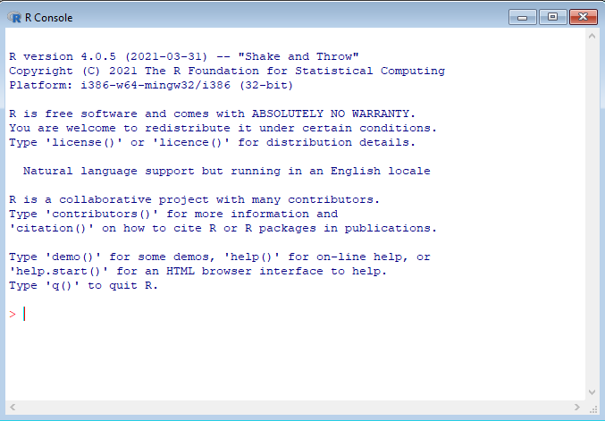

This is the command line screen. You can enter commands but need to know the syntax. There is a simpler approach to running R, called Rcmdr (R Commander). If you are running a Whitman computer, Rcmdr is already installed. If not, you need to install it.

**Installing R Commander**

Follow these steps only if you don’t already have Rcmdr installed.

1. In R, type the command:

install.packages("Rcmdr", dependencies = TRUE)

1. In the CRAN mirror, select the location closest to you; use a USA location near you, then click OK.
2. If prompted to create a personal library, click Yes.
3. If prompted to add missing packages, click Yes.

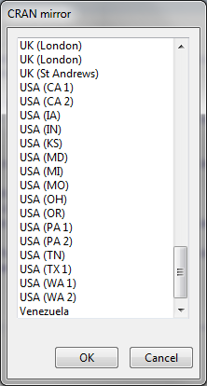

**Launch Rcmdr (R Commander)**

Rcmdr is a graphical user interface (GUI) that is easier to use than the command line. To launch Rcmdr:

1. Type:

library(Rcmdr)

1. If you receive a warning message that some packages are missing, it will ask if you want them installed. Click Yes.
2. On the Install Missing Packages screen, click OK.
3. R will install the necessary software.
4. The R Commander screen will appear.

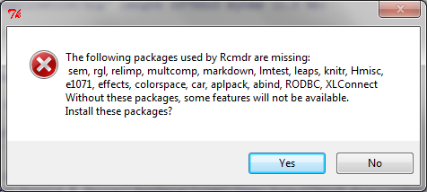

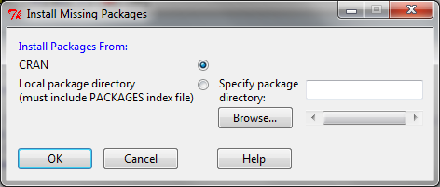

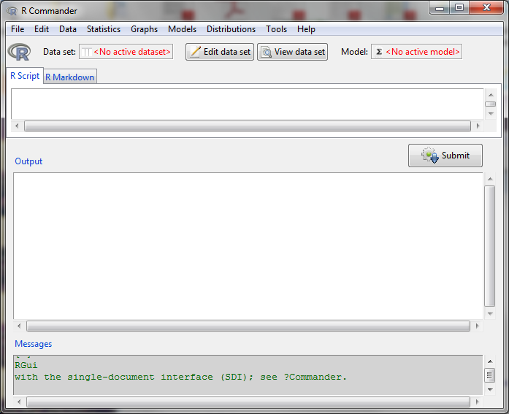

**9.2.1 Regression, Diagnostics, and Corrections Overview**

Linear regression is a technique that calculates the relationship between a dependent variable Y and one or more independent variables, or Xs. Assume that you have data similar to the picture below.

Scatter plot of data

You can calculate a regression trend line based on the data. This dashed line represents which is the estimate of the Y equation.

Linear regression line through data

The vertical distance between the line and the data point is called the residual or error term.

**Regression Diagnostics**

There are several assumptions of linear regression:

1. The relationships are linear.
2. The X variables (explanatory variables) are not correlated.
3. Distribution of residuals:
   1. The error terms have constant variance.
   2. The errors terms are not correlated.
   3. There are no outliers.

**Assumption 1: The relationship is linear.**

Let’s examine each of these assumptions. In the pictures below, the left picture has data with a linear relationship, the right picture had nonlinear data. Linear regression can only be used on data with a linear relationship. Transformations can be used to transform nonlinear data into linear data. For example, exponential data like the data on the right can be converted into a linear relationship by taking the logarithm of both the Y and X variables.

|  |  |
| --- | --- |
| Scatterplot of linear data | Scatterplot of non-linear data |

**Effects of Nonlinearity**

If the data is not linear, and you use a linear regression, the regression will generate biased (incorrect) coefficients.

**Test for Linearity**

The Ramsey Regression Equation Specification Error Test (RESET) (1969) to test for linearity

**Solution to Nonlinearity**

The best solution for nonlinear data is to transform the data using logarithms, squares, square roots, or inverses (1/variable). There are more advanced techniques which can assist in determining the correct transformation (Box-Cox for the Y variable; Box-Tidwell for the X variables).

**Assumption 2: The X variables are not correlated (no multicollinearity).**

When including more than one explanatory or independent variable (i.e., X variable) in an analysis, you must ensure that they are not related to each other. If you plot the X variables, you should see no pattern, such as the picture on the left between variables X1 and X2. If you see a relationship, such as on the right between X2 and X3, then multicollinearity exists.

|  |  |
| --- | --- |
| Scatterplot showing no multi-collinearity | Scatterplot showing multi-collinearity |

**Effects of Multicollinearity**

If the independent variables (x-variables are correlated, the sign +/- will be reversed on one of the coefficients).

**Test for Multicollinearity**

The Variance Inflation Factor test of correlated explanatory variables

**Solution to Multicollinearity**

If two or more variables are collinear (highly correlated), there are three solutions:

1. Combine the variables, for example, take an average of the variables.
2. Drop one of the variables.
3. Use factor analysis to combine variables.

**Assumption 3a: The error terms do not have constant variance (heteroscedasticity).**

The residuals (error terms) of a regression must have constant variance over a range of X values. If the size of the error terms depends on an X value, this is called heteroscedasticity. Heteroscedasticity is often caused by performing a linear regression on nonlinear data. In the charts below, there is no relationship between the X variable and the error term. On the right, the residuals or errors are heteroscedastic; the size of the error is dependent on the X value.

The picture below shows heteroscedastic residuals. Notice that the variability of the errors or residuals tends to grow larger for larger values of X. The picture on the right has lines added indicating the general growth in variability.

|  |  |
| --- | --- |
| Scatterplot with Heteroscedasticity | Scatterplot with Heteroscedasticity and wedge shaped pattern |

**Effects of Heteroscedasticity**

If the residuals are heteroscedastic, the standard errors and *p*-values will be incorrect.

**Test for Heteroscedasticity**

Breusch-Pagan test of heteroscedasticity

**Solution to Heteroscedasticity**

Heteroscedasticity is often caused by performing linear regression on nonlinear data. Generally, solving nonlinearity problems with transformations reduces or eliminates heteroscedasticity. If the problem is not completely resolved with a transformation, additional advanced techniques including Huber regression can correct lingering issues.

**Assumption 3b: The error terms are not correlated (serial correlation).**

When dealing with data over time, it’s possible for the error terms from one time period to be highly correlated with the previous time period. This is called serial correlation. The error terms or residuals will have a pattern that is not random, such as in the picture below.

**Scatterplot showing serial correlation**

**Effects of Serial Correlation**

If the residuals have serial correlation, the standard errors will be underestimated, and the *p*-values will be incorrect.

**Test for Serial Correlation**

Durbin-Watson test of serial correlation

**Solution to Serial Correlation**

To correct for serial correlation there are several techniques in time series, including Prais-Winsten, rho differencing, ARCH, and Cochrane-Orcutt.

**Assumption 3c: There are no outliers.**

An outlier is a data point that is significantly different from other data points. Outliers are often the result of unusual circumstances or data entry errors. The data below has an outlier.

Scatterplot with outlier

**Effect of Outliers**

If outliers exist in the data, the coefficients (slopes) will be incorrect.

**Test for Outliers**

Bonferroni outlier test

**Solution to Outliers**

If the data point is clearly an outlier, you can drop the bad data point, but mention in your analysis that you dropped outliers.

**9.3.2 Regression Linearity Test (RESET) Demo**

**Download Data Sets**

Download the following files:

Week9-oj-data.xlsx

**Loading Data**

To load data into R:

1. Click on Data at the top of the screen.
2. Click on Import Data > from Excel file.
3. Enter the name that you would like to use for this data set; type in oj.
4. Locate the file on your computer, then Open.

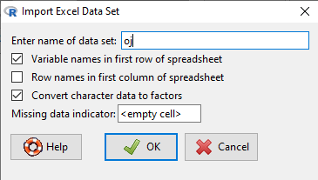

**Linear Regression**

Linear regression of the log of sales against age, income and price can be performed by:

1. Click on Statistics, Fit Models, Linear Regression.
2. For response variable, click on move (which is the volume of products moved or sold).
3. For explanatory variables, hold down the control key and click on AGE60, INCOME, price.
4. Click OK.

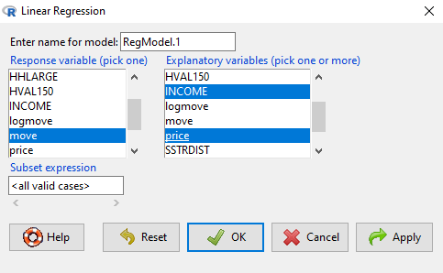

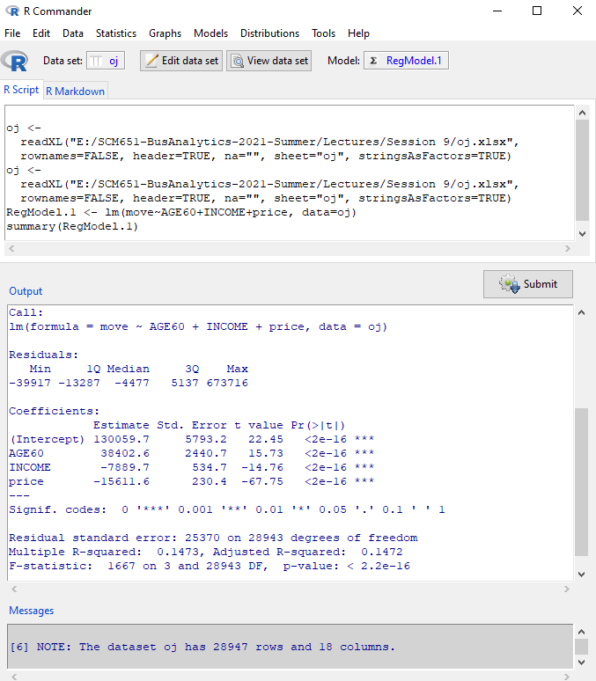

**Assumption 1: Linearity**

**Ramsey Regression Equation Specification Error Test (RESET) (1969) to test for linearity**

To test if your equation is linear:

1. Click on Models, Numerical Diagnostics, RESET Test for Nonlinearity.
2. Click OK.

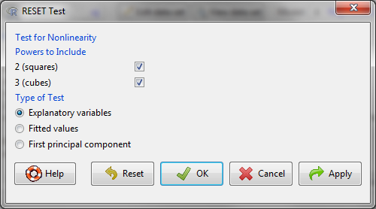

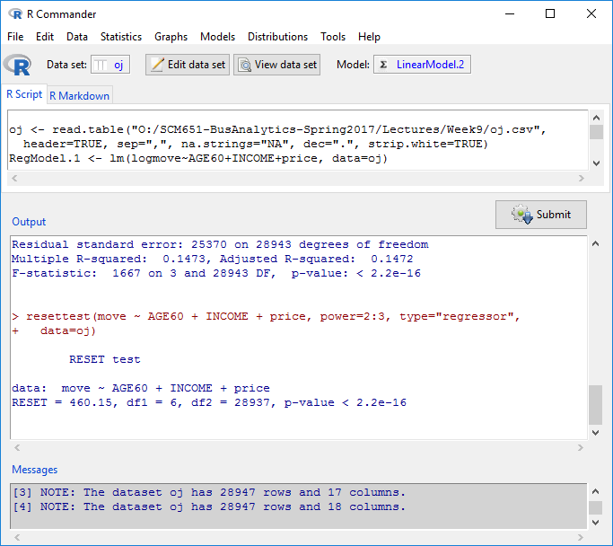

1. If the *p*-value is less than 0.05, then there is a nonlinearity problem.

**9.3.3 R: Box-Cox Correction for the Y-Variable**

Nonlinearity can result from a nonlinear dependent (Y) variable or a nonlinear independent (X) variable. The Box-Cox technique corrects for nonlinearity in Y; the Box-Tidwell technique corrects for nonlinearity in X.

When the nonlinearity test indicates that your data is nonlinear, first use the Box-Cox technique (George Box and D. R. Cox 1964) to determine if the Y variable (response variable) is the problem and identify the solution. The solution is usually a transformation.

Install the Box-Cox tool set:

1. In the RGui screen, type:

install.packages("MASS", dependencies=TRUE)

library(MASS)

1. Type the following command:

boxcox(lm(move~AGE60+INCOME+price,data=oj),lambda=seq(-2,2,by=.1))

1. The following components are necessary for boxcox:
   1. boxcox – name of command
   2. lm – linear model
   3. move~AGE60+INCOME+price – model formulation
   4. data=oj – source of data
   5. lambda=seq(-2,2,by.1) – range of lambda and increment
2. Look on the chart for where lambda peaks; this is the maximum likelihood.
3. In this example, it peaks around a lambda value of zero.
4. Interpretation:
   1. -2 means that you should transform Y by raising it to the -2 power (1/Y2)
   2. -1 means that you should transform Y by raising it to the -1 power (1/Y)
   3. 0 means that you should transform Y by taking the logarithm (log(Y))
   4. 1 means that you should raise Y to the 1 power (Y)
   5. 2 means that you should raise Y to the 2 power (Y2)
5. What should the transformation of our variable “move” be?

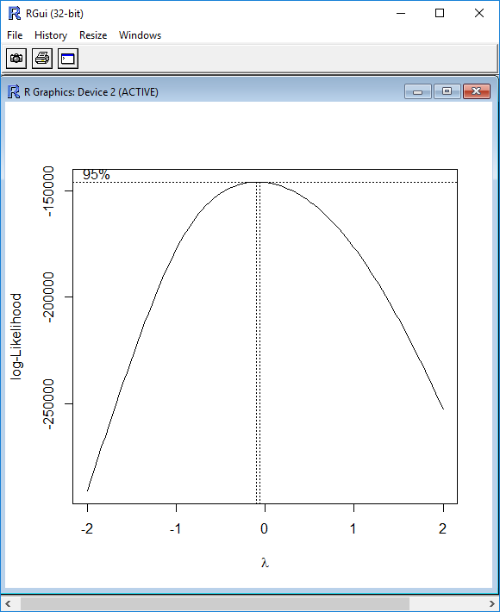

**Testing the Equation after Correction for Nonlinearity in Y**

1. Next, run the linear regression for logmove instead of move.
2. Click on Statistics, Fit Models, Linear Regression.
3. For response variable, click on logmove.
4. For explanatory variables, hold down the control key and click on AGE60, INCOME, price.
5. Click OK.

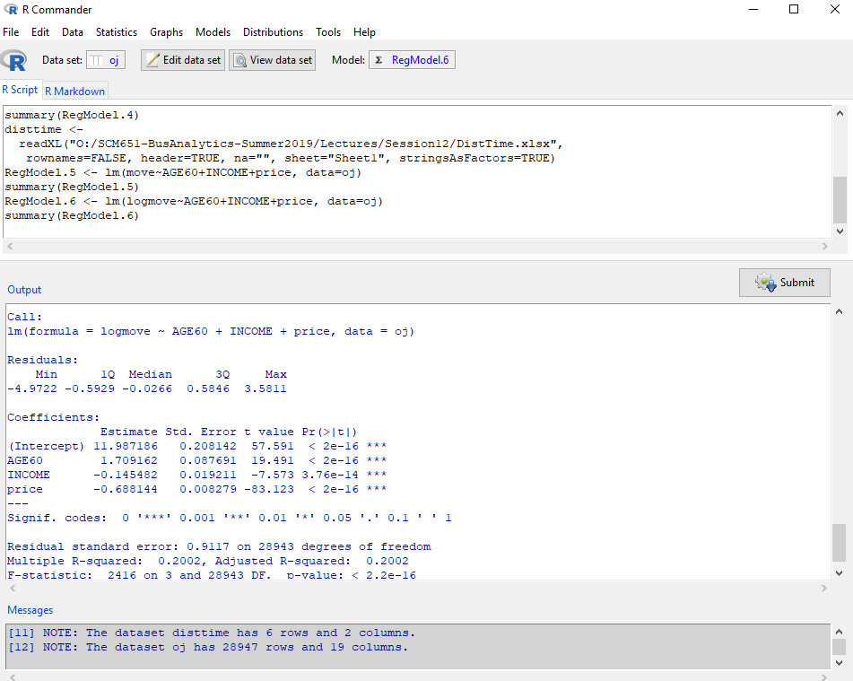

1. The R-squared for logmove~AGE60+INCOME+price is 0.2002.
2. Run the RESET test again. Do we still have nonlinearity?

**9.3.4 R: Box-Tidwell Correction for the X-Variable**

After correcting for any nonlinearity in the Y-variable, next correct for nonlinearity in the X-variable. The Box-Tidwell technique (George Box and P. W. Tidwell 1962) corrects for nonlinear independent variables.

1. In the RGui screen, type:

install.packages("car", dependencies=TRUE)

1. Type:

library(car)

1. Type the following command:
2. The following components are necessary for boxTidwell:
   1. boxTidwell – name of command
   2. logmove~price – model formulation, only one X variable at a time
   3. data=oj – source of data
   4. tol – tolerance level, stopping threshold
   5. max.iter=25 – maximum number of iterations for the maximum likelihood

MLE of lambda Score Statistic (z) Pr(>|z|)

-1.0341 34.858 < 2.2e-16 ***

---

Signif. codes: 0 '***' 0.001 '**' 0.01 '*' 0.05 '.' 0.1 ' ' 1

iterations = 4

1. Interpretation:
   1. -2 means that you should transform X by raising it to the -2 power (1/X2)
   2. -1 means that you should transform X by raising it to the -1 power (1/X)
   3. 0 means that you should transform X by taking the logarithm (log(X))
   4. 1 means that you should raise X to the 1 power (X)
   5. 2 means that you should raise X to the 2 power (X2)
2. What should the transformation of our variable “price” be?
3. We need to create a new variable 1/X.
4. In Rcmdr, click on Data, Manage variables in active data set, Compute new variable.
5. For New variable name, enter invprice (for inverse of price).
6. In Expression to compute, enter 1/price.
7. Click OK.

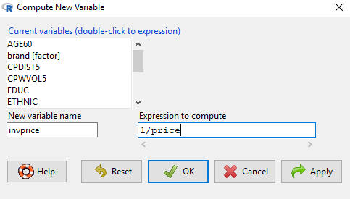

1. Next, run the linear regression for logmove~AGE60+INCOME+invprice.
2. Click on Statistics, Fit Models, Linear Regression.
3. For response variable, click on logmove.
4. For explanatory variables, hold down the control key and click on AGE60, INCOME, invprice.
5. Click OK.

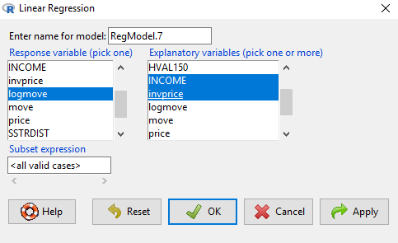

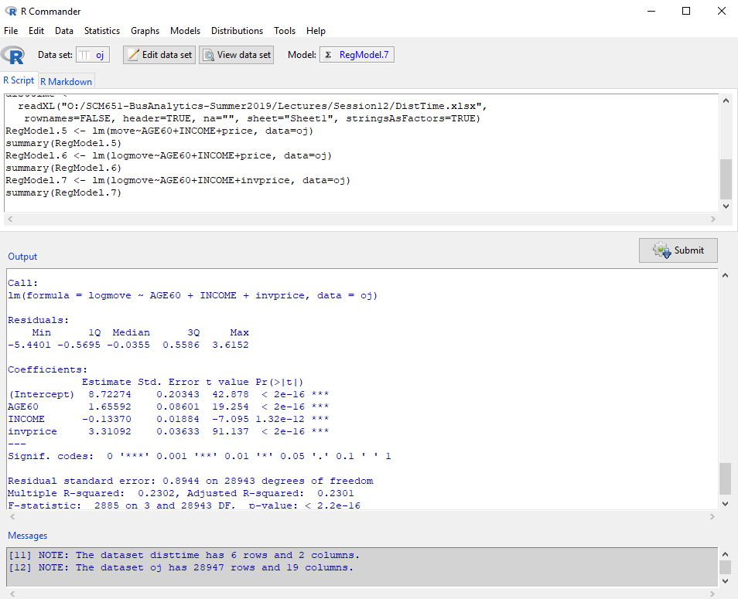

1. The R-squared for logmove~AGE60+INCOME+invprice is 0.2302.

**9.4.2 R: Collinearity Test (VIF) Demo**

**Assumption 2: Multicollinearity**

**Variance Inflation Factor (VIF) Test of Correlated Explanatory Variables**

To calculate the variance inflation factor:

1. Click on Models, Numerical Diagnostics, Variance Inflation Factor.

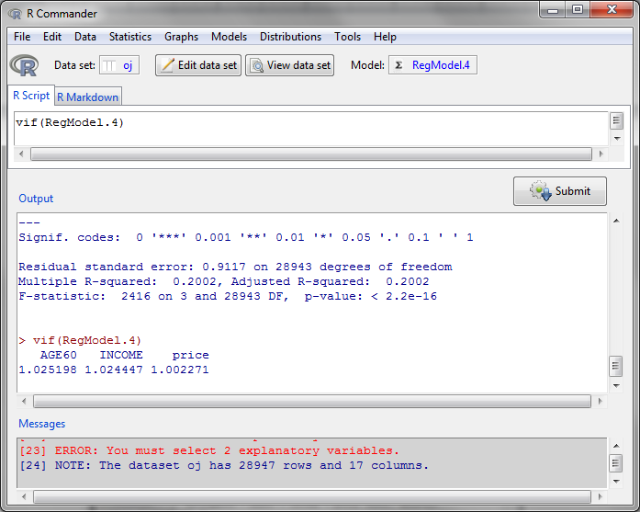

1. If the variance inflation factors are less than 10, then there is no multicollinearity. If multicollinearity exists, then drop variables or combine variables.
2. Factor analysis is one technique for combining variables. We will cover factor analysis later; it’s not necessary for this model.

**9.4.3 R: Factor Analysis**

When variables are collinear, you must combine or drop some variables. Factor analysis identifies how many unique concepts are in the variables and combines them into factors.

**Install**

To install the modules, we need the psych library. Enter the following commands:

install.packages("psych",dependencies=TRUE)

library(psych)

**Download Data Sets**

The orange juice data set does not have a problem with multicollinearity, so we will use a different data set to demonstrate a solution. Download the Week9-teaching-data.xlsx file. This data set is from Charles Zaiontz, from the website:

http://www.real-statistics.com/multivariate-statistics/factor-analysis/factor-analysis-example/

**Loading Data**

To load data into R:

1. Click on Data at the top of the screen.
2. Click on Import Data > From Excel file …
3. Enter the name that you would like to use for this data set; type in teaching, then OK.
4. Click on the Teaching file, then Open.
5. In this example, the Teaching spreadsheet has two worksheets, Teaching and Reference; click on Teaching, then OK.

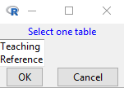

1. In Rcmdr, click on View data.

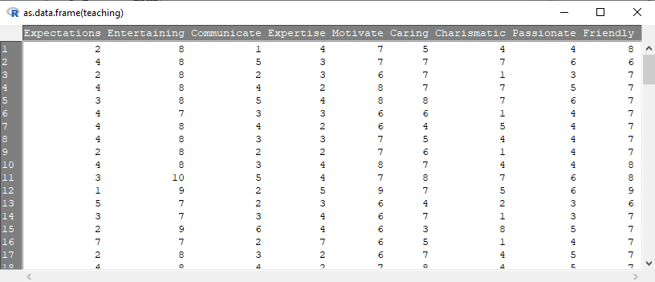

1. This data represents what students feel are important characteristics for an instructor.
2. The characteristics are:

Expectations Setting high expectations for the students

Entertaining Entertaining

Communicate Able to communicate effectively

Expertise Having expertise in their subject

Motivate Able to motivate

Caring Caring

Charismatic Charismatic

Passion Having a passion for teaching

Friendly Friendly and easy-going

1. A scree plot will indicate how the measures above collapse into unique factors. Type the command:

scree(teaching)

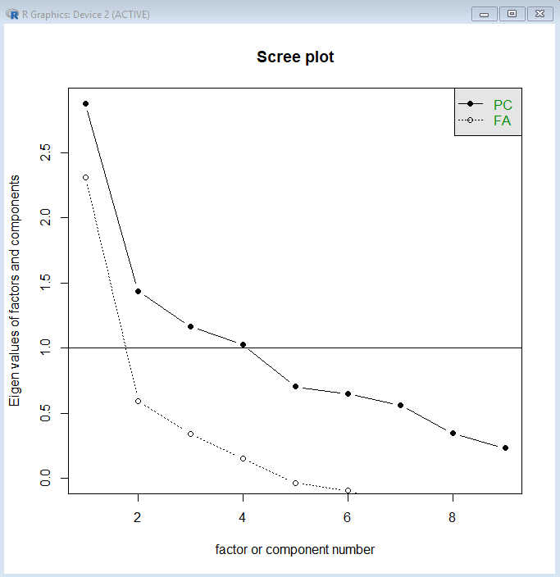

1. There are two techniques represented above, principal component analysis (PC) and factor analysis (FA). The left side of the chart indicates eigenvalues. The Kaiser criterion (Kaiser 1960) recommends that the number of principal components or factors is the number of dots above the 1.0 line (eigenvalue > 1.0).
2. Now determine exactly how many factors we need.
3. Click on Statistics, Dimensional Analysis, Factor Analysis.
4. Highlight all the variables by holding down the control key and clicking each variable (or click on the first, hold the shift button down, then click on the last variable). Click OK.

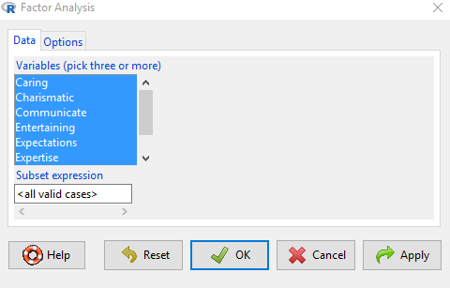

1. When asked for number of factors to extract, change to 2, then OK.

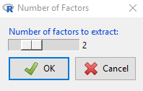

1. The hypothesis is that two factors are sufficient. If *p* < 0.05, then two are not sufficient and we need to test three factors. In this case, *p* = 0.00152, so two is not sufficient.

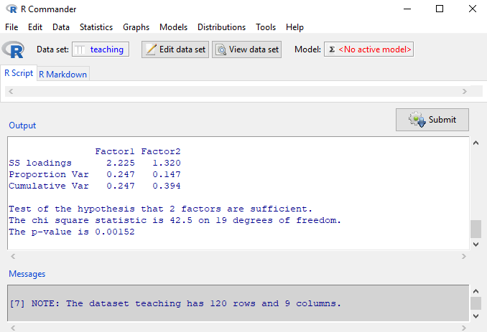

1. Click on Statistics, Dimensional Analysis, Factor Analysis, then OK.
2. Change number of factors to 3, then OK.

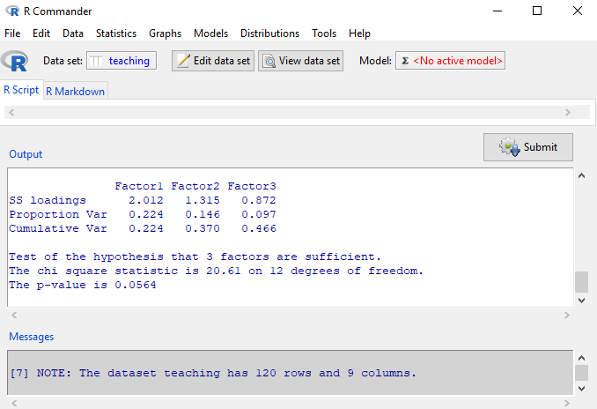

1. Now, *p* = 0.0564. Therefore, three factors are sufficient. This means that the original variables can be collapsed into three concepts.
2. Click on Statistics, Dimensional Analysis, Factor Analysis.
3. Click on the Options tab, and check the button for Regression method, then OK.
4. Set the Number of factors to extract to 3, the OK.

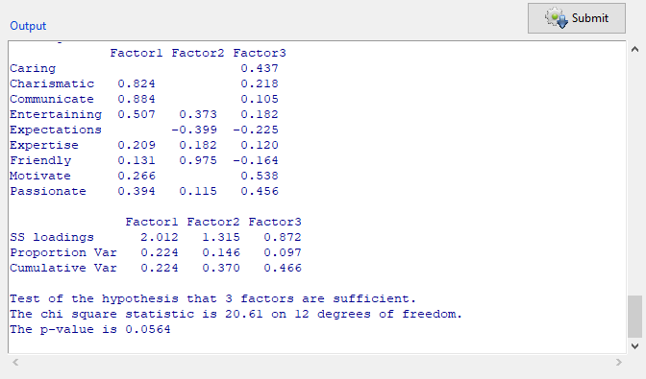

1. There are three factors. The numbers in the columns are loadings, which measure how much the original variable influences the factor. Which variables have a load of more than 0.500 for factor 1? Factor 2? Factor 3?
2. How would you interpret Factors 1, 2, 3?
3. In Rcmdr, click on View data; scroll to the right.
4. The three new variables are F1, F2, F3, our new factors, calculated from the original variables.
5. These are the variables that you would use in a regression.
6. By selecting the varimax rotation, the factors F1, F2, F3 will not be correlated, so multicollinearity in regression will not be a problem.

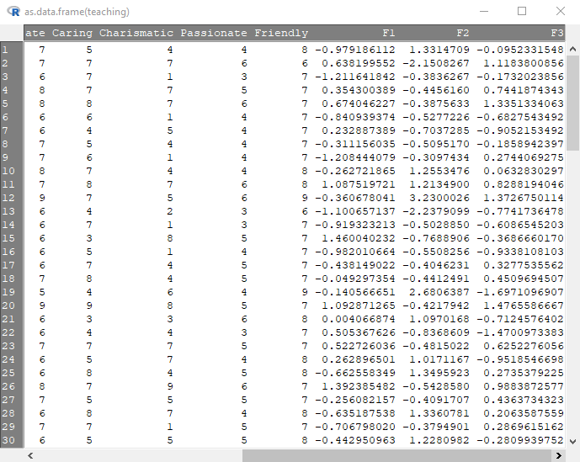

**9.5.2 R: Heteroscedasticity Test (Breusch-Pagan) Demo**

**Assumption 3a: Heteroscedasticity**

**Breusch-Pagan Test of Heteroscedasticity**

Heteroscedasticity means that the error terms are vary depending on values of the explanatory variables. To test for heteroscedasticity:

1. Click on Models, Numerical Diagnostics, Breusch-Pagan test for heteroscedasticity.
2. Double click on AGE60, INCOME, invprice.
3. Click on OK.

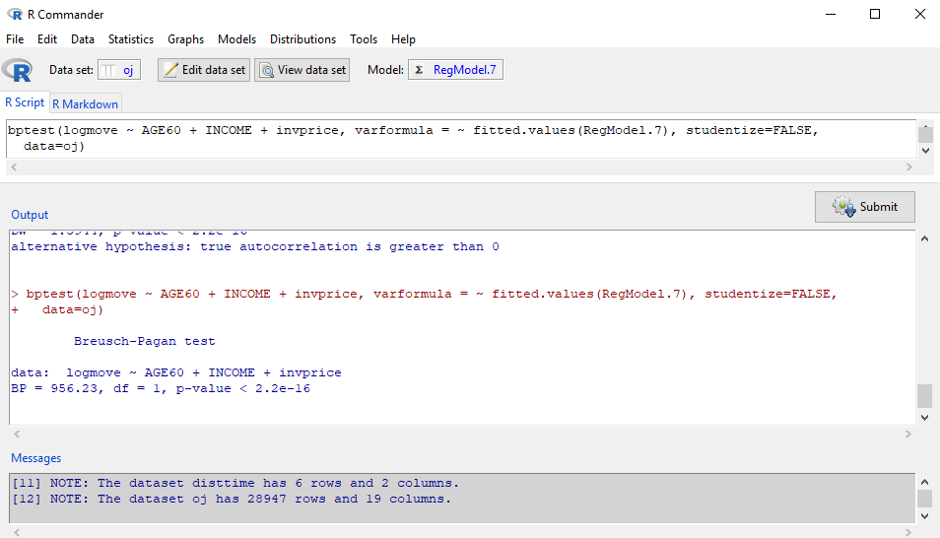

1. If the *p*-value is less than 0.05, then there is a problem with heteroscedasticity. Generally, this is a sign that the equation is nonlinear and you forgot to correct for nonlinearity.

**9.5.3 R: Huber Regression**

1. If you have already corrected for nonlinearity, then more sophisticated techniques (robust Huber regression for heteroscedasticity) must be used. Install MASS if not already installed.

install.packages("MASS",dependencies=TRUE)

library(MASS)

summary(rr.huber <- rlm(logmove ~ AGE60 + INCOME + invprice, data=oj))

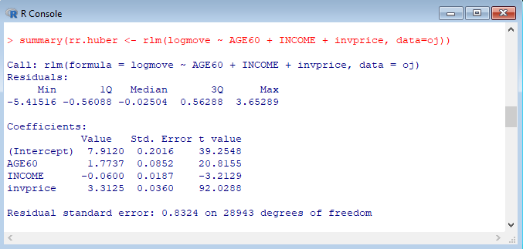

**9.6.2 R: Serial Correlation Test (Durbin-Watson) Test**

**Assumption 3b: The residuals are not correlated (violation: serial correlation).**

**Durbin-Watson Test of Serial Correlation**

Serial correlation occurs when the errors terms are correlated. To test this:

1. Click on Models, Numerical Diagnostics, Durbin-Watson test for autocorrelation.
2. Select rho > 0, then OK.

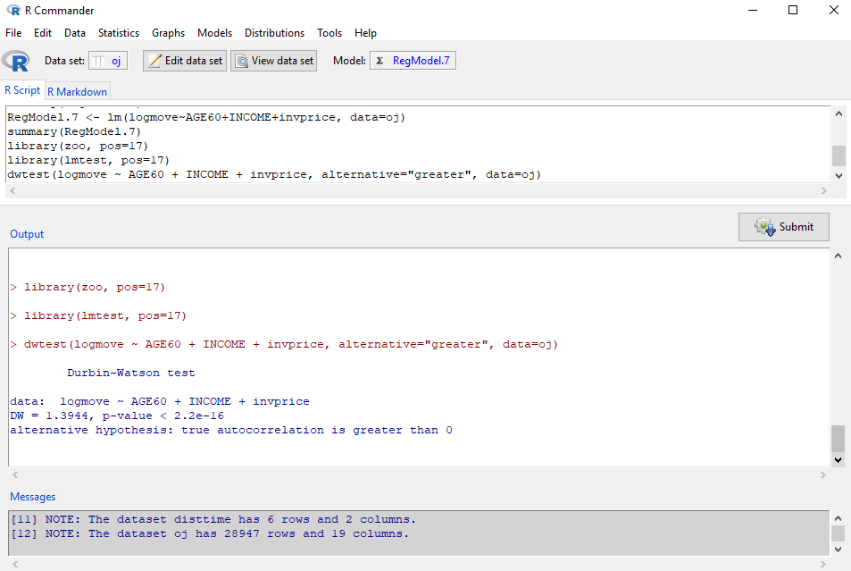

1. If the *p*-value is less than 0.05, there is a problem with serial correlation.

**9.6.3 R: Prais-Winsten Correction for Serial Correlation**

*There are several techniques for correction of serial correlation, including Cochrane-Orcutt* (Cochrane and Orcutt 1949), Prais-Winsten (Prais and Winsten 1954) and rho differencing.

install.packages("prais",dependencies=TRUE)

library(prais)

pw <- prais_winsten(logmove ~ AGE60 + INCOME + invprice, data=oj, index=NULL)

summary(pw)

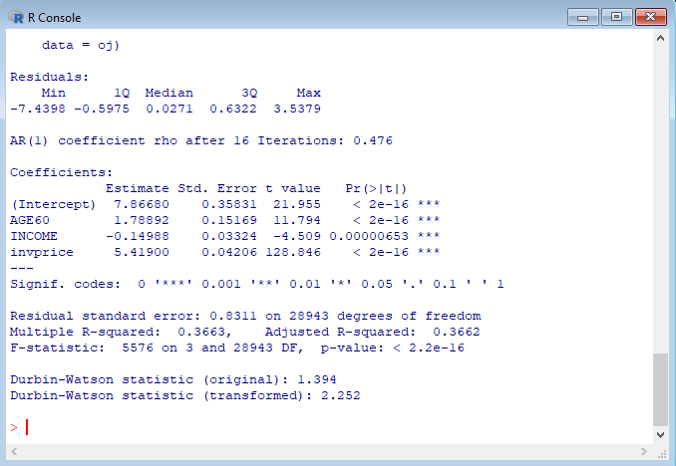

**9.7.2 R: Outlier Test (Bonferroni) Demo**

**Assumption 3c: Outliers**

**Bonferroni Outlier Test**

Outliers are extreme data points that can influence the results and lead to incorrect coefficients. To identify outliers:

1. Click on Models, Numerical Diagnostics, Bonferroni outlier test.

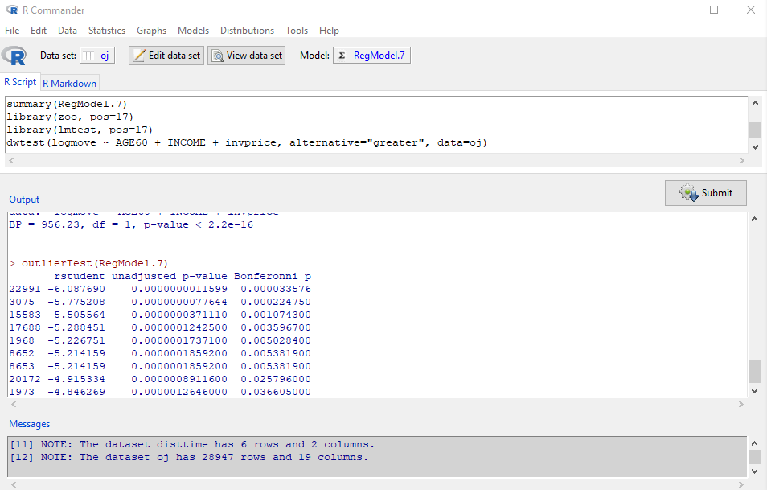

1. Outliers have a Bonferonni *p*-value < 0.05.
2. If there are no outliers, Rcmdr will show one data point, but its *p*-value will not be less than 0.05. This shows the worst data point, but it is not an outlier.
3. In this example, there are several outliers. It is usually best to remove these data points from your data and retest the model. Always document that you removed outliers.

9.8.1 **Scientific Example: Test of Assumptions**

Data sets do not need to be large to find interesting results. Load the following data with only six observations, perform a regression of distance on time, then use Box-Cox to find the form of the equation.

1. Download the Week9-disttime-data file.
2. Click on Data at the top of the screen.
3. Click on Import Data > From Excel file …
4. Enter the name that you would like to use for this data set; type in DistTime.
5. Click OK.

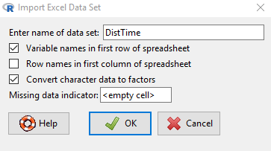

1. Click on the DistTime file, then Open.
2. Click on View data set to view the six data observations.

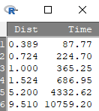

1. Run the regression by clicking on Statistics, Fit models, Linear regression.
2. Click on Dist for the Response variable (Y) and Time for the Explanatory variable (X).
3. Click OK.

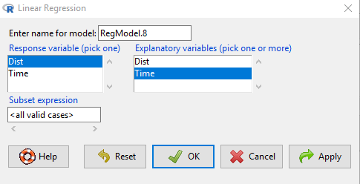

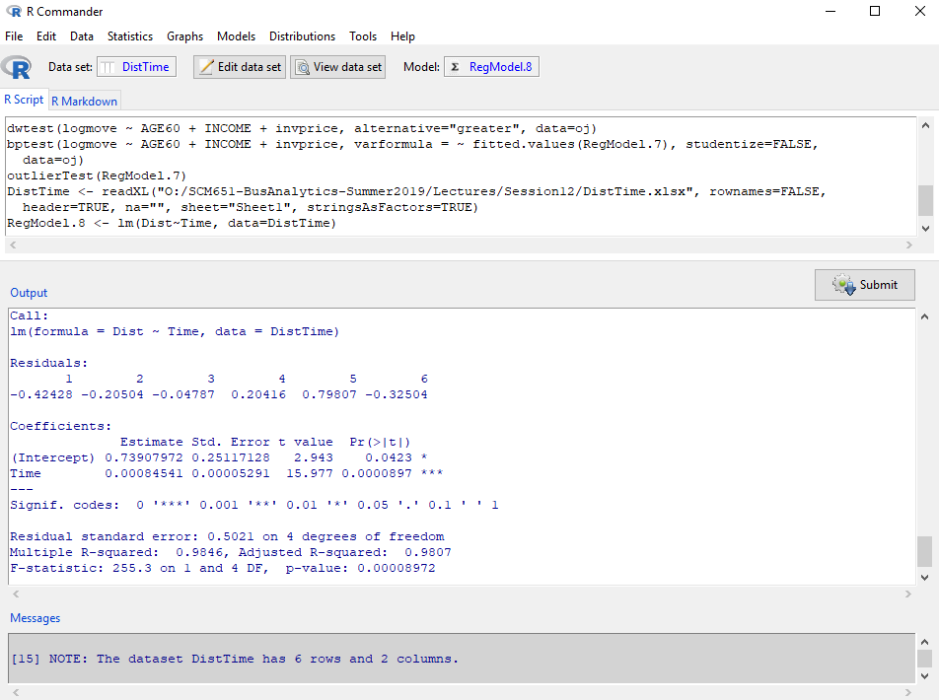

1. Run the RESET test to test for nonlinearity.
2. Next run Box-Cox:

boxcox(lm(Dist~Time,data=DistTime),lambda=seq(-2,2,by=.1))

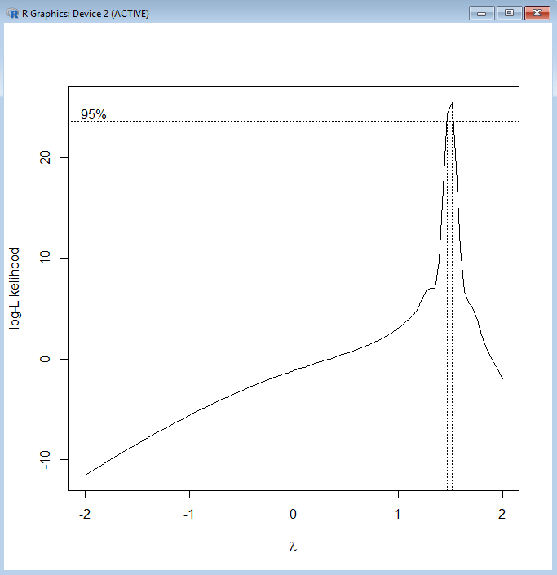

1. The lambda is 1.5, or written as a fraction, 3/2.
2. The equation then is:

Dist3/2 = β*Time

1. Taking the square of each side, we get:

Dist3 = β'*Time2

1. This is Kepler’s third law of planetary motion (Kepler 1619).

**9.9.2 R: Data Mining Using Rattle Demo**

Data mining tools allow you to explore in more detail groupings of data and more sophisticated analysis. Rattle is an add-in to R that facilitates data mining.

**Installing Rattle**

Follow these steps only if you do not already have Rattle installed.

1. To install Rattle, type the following commands:

install.packages("rattle", dependencies=TRUE)

library(rattle)

rattle()

1. When it asks “Would you like Rattle to install …,” type yes.
2. If you receive an error message about GTK+, then install GTK+ by clicking OK.
3. If you receive an error message about XML, click Yes to install.
4. Similarly, for cairoDevice.

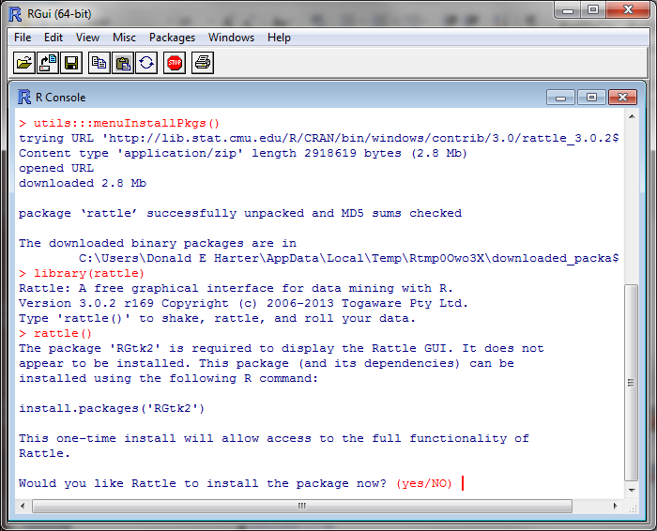

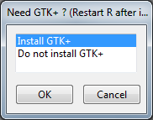

**Loading Data**

The package R has some built in data sets. To load data into R:

1. In the R Data Miner [Rattle] window, click on the Data tab.
2. Check that Source indicates Library.
3. Next to Data Name, use the drop-down menu to select audit: rattle: Sample dataset.
4. Click on Execute.
5. This data set represents income tax audit data.

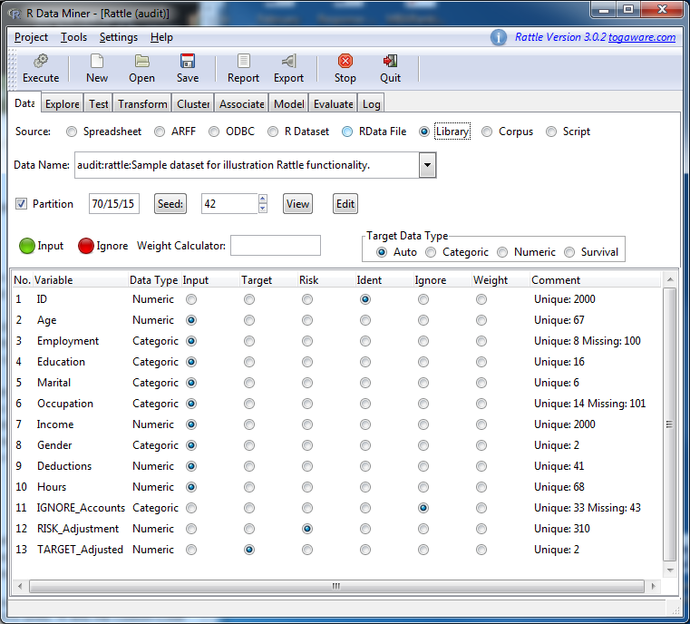

**Summary Statistics**

1. Click on the tab Explore.
2. Next to Type: check the radio button Summary.
3. Click on Execute.

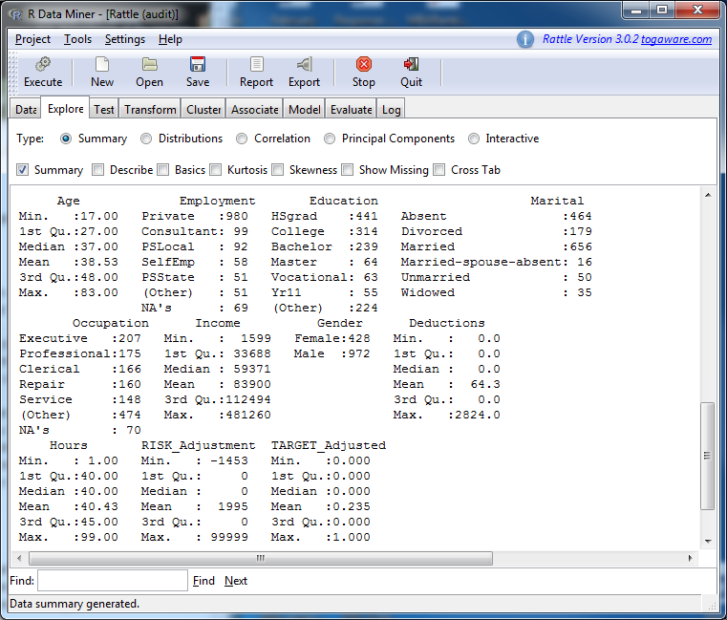

**9.10.2 R: Benford’s Law: Detecting Fraud Demo**

In auditing (accounting, financial audits, tax audits), there is a rule called Benford’s law that specifies the frequency of the first digit in almost any financial number. For example, approximately 30% of financial numbers start with the digit 1. The frequency of first digits is:

1. 30.1%
2. 17.6%
3. 12.5%
4. 9.7%
5. 7.9%
6. 6.7%
7. 5.8%
8. 5.1%
9. 4.6%

Deviations from this distribution is a potential indicator of fraud.

The data set that was loaded describes 2,000 income tax audits. To compare the result of income tax audits to Benford’s law:

1. Click on the tab Explore.
2. Check the radio button Distributions.
3. In the line for Income, check the box under Benford.
4. Click Execute.

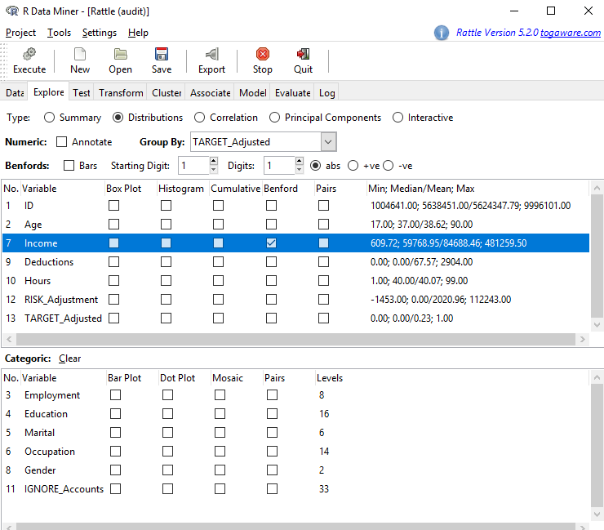

The Benford line is the expected frequency of the first digit of taxpayers’ income. The All line is the frequency of the first digit of all tax returns filed for 2,000 people. The 1 line is the frequency of first digits of income for taxpayers who were asked to fix their tax returns. The 0 line is those taxpayers were not asked to fix tax returns. The 1 line departs significantly from the Benford line.

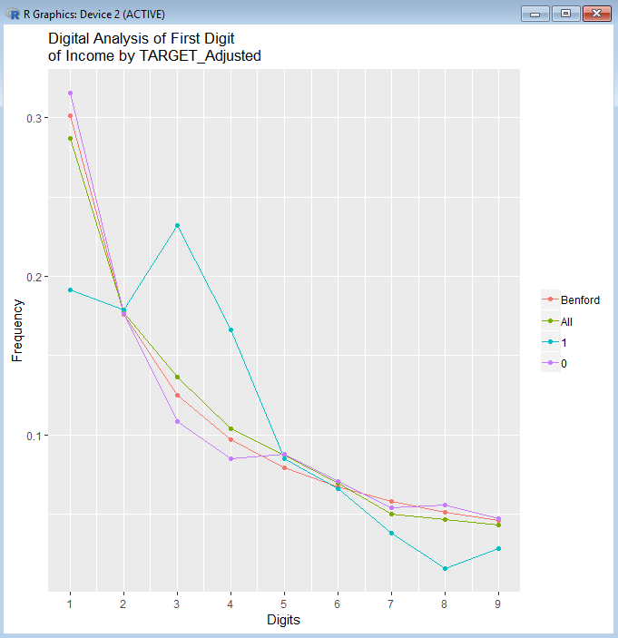

To get a sense of whether men or women income taxpayers are different:

1. Click on the Explore tab.
2. Click on the radio button Distributions.
3. For the Income variable, check Benford.
4. In the Group By:, use the drop down arrow and select Gender.
5. Click Execute.

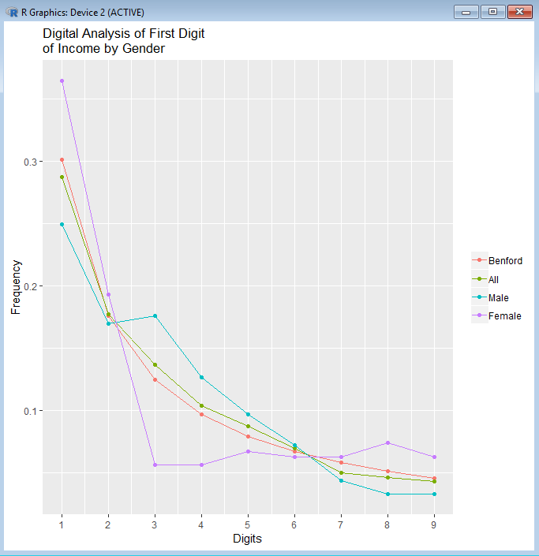

1. Are the incomes of men and women different?

**Statistical Tests**

Next determine if the distribution of tax violators (coded as 1) were different from nonviolators. Test the means of the two distributions to see if they are different.

1. Click on the tab Test.
2. For Two-Sample Tests, click on the radio button T-test.
3. For Sample 1, use the drop-down arrow to select Income.
4. Click Execute.

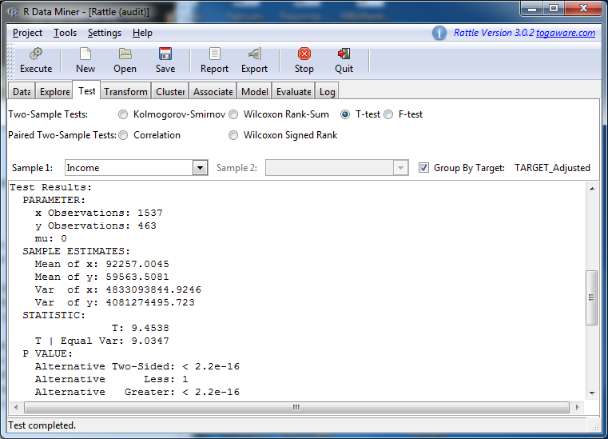

1. The X observation is for those coded as 0 (did not commit fraud); Y observation for those coded 1 (did commit fraud). Look at the *p*-value for the test. Are the two groups different?
2. What is the average income for each group?
3. Which group appears to be misreporting their income more frequently? The higher or lower income group?